People’s committee  _____________  Commune/Ward : Tho Thanh  District:  Province/City: | Socialist republic of Vietnam  Independence - Freedom - Happiness  ______________  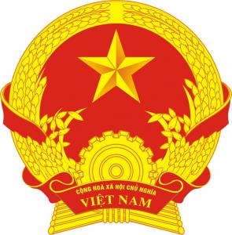  NGHE AN DEPARTMENT OF JUSTICE  CONTROLS THE CIVIL STATUS FORM | Form TP/HT-1999-A.2  Nº.: 46  Book Nº: 1

birth certificate

Full name : NGUYEN THI THUY Sex: Female
Date of birth : 3/6/2003 (The third day of June, Two thousand and three)
Place of birth (1) : Tho Thanh, Yen Thanh, Nghe An
01/2004 (Decision No.: 1203 QD/TP-HT) QD.I
Ethnic group : Kinh Nationality: Vietnamese
Native place (2) : Tho Thanh, Yen Thanh, Nghe An
Statement of parents | father | mother
Full name | NGUYEN VAN NANG | NGUYEN THI THAM
Date of birth | 1974 | 1976
Ethnic group | Kinh | Kinh
Nationality | Vietnamese | Vietnamese
Native place (2) | Tho Thanh, Yen Thanh, Nghe An | Tho Thanh, Yen Thanh, Nghe An
Permanent /Temporary residence (3) | Tho Thanh, Yen Thanh, Nghe An | Tho Thanh, Yen Thanh, Nghe An
Full name, age, permanent residence and ID Card Nº. of the declarant:
Nguyen Thi Tham
Relationship with the person declared: Mother

Declarant | Registrar  (Signed)  Vo Duc Thong | April 17th, 2004  On behalf of People's Committee  VICE-chairman  (Signed and sealed)  CHU MINH LY

Note of changeS of in the birth CERTIFICATe

No | Date/month/year | Noted contents  (seal on noted content) | Basis of note | Full name of registrar | Signature, full name, seal of Director of Justice Department
1 | 2 | 3 | 4 | 5 | 6

